PERSONAL DATES­­

FULL NAME

ID NUMBER

PLACE AND DATE OF BIRTH

ADDRESS

CELPHONE

EMAIL

WORK EXPERIENCE

PERSONAL BOSS

PRIVATE SECURITY

DRIVER

CARPINTER

ASISTENT

PERSONAL REFERENCE

RICARDO CASTILLO

HECTOR MEJIA

JULISSA ROMERO

SPECIAL TRAINING

TALABARTERIA

EDUCATION

PRIMARY EDUCATION

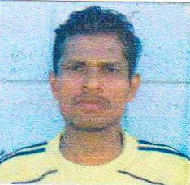Isac Lozano Ramirez

1802-1977-00189

Teguajal,Arenal,Yoro,HONDURAS

Teguajal,Arenal,Yoro,Honduras

3148-7583

ilozanoramirz@yahoo.com

Rancho Leo

January 2000-December 2004

2227-7038

Joselyn Ponce

February 2005-September 2007

9610-6723

Material Construction

Junio 2008-november 2009

3372-8461 2425-3955

Unie Carleen Munoz

Junio 2010-January 2011

2425-3960

Standard Fruit Company

October 2011-July 2012

Edgar Murillo

9990-7682

9984-8406

9742-5151

9590-3884

Work whit Lader-cuero

January-may 2008

Institute LUCAS QUEZADA

Teguajal,Arenal,Yoro

1-6 grade

1984-1990

